**Python Programming Lab**

**Week -1:**

Use a web browser to go to the Python website http://python.org.

This page contains information about Python and links to Python-related pages, and it gives you the ability to search the Python documentation.

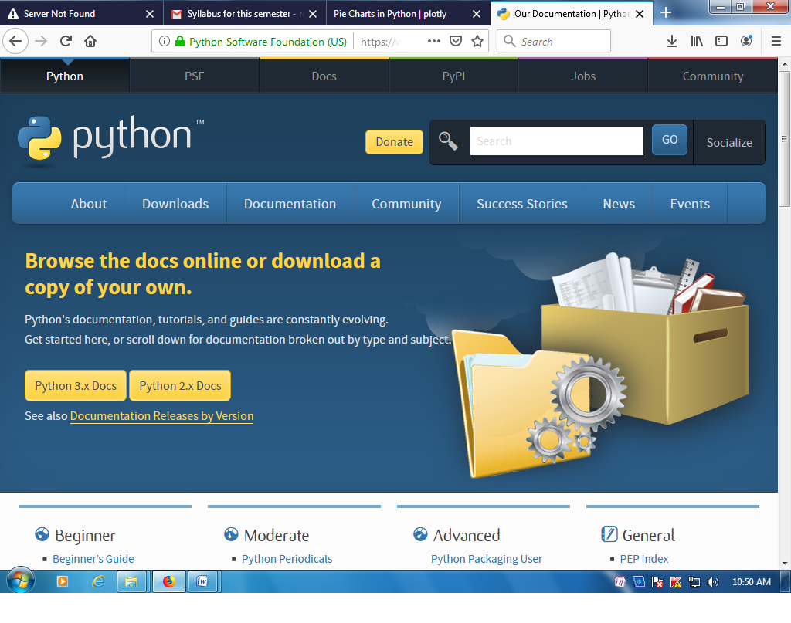

2. Start the Python interpreter and type help() to start the online help utility.

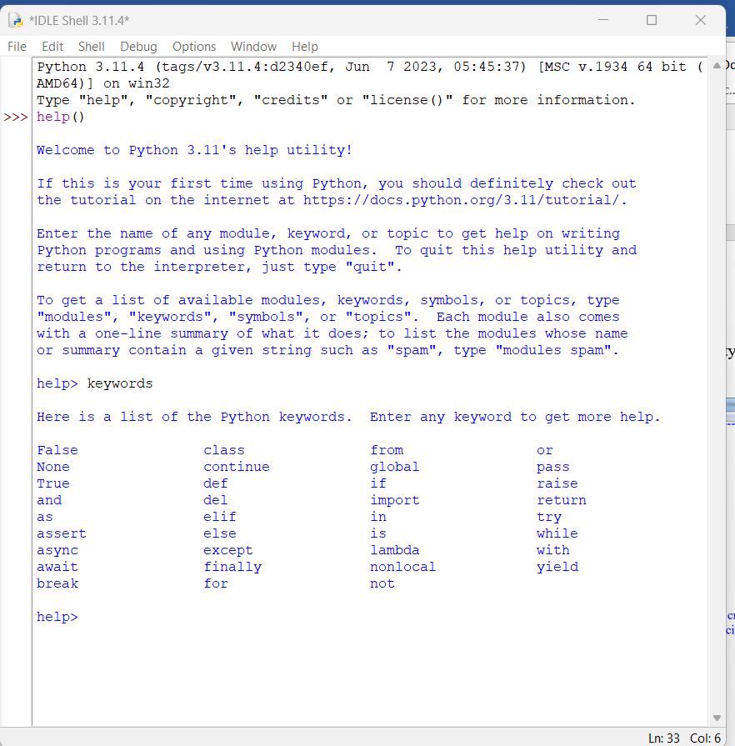

3. Start Python interpreter and use it as Calculator.

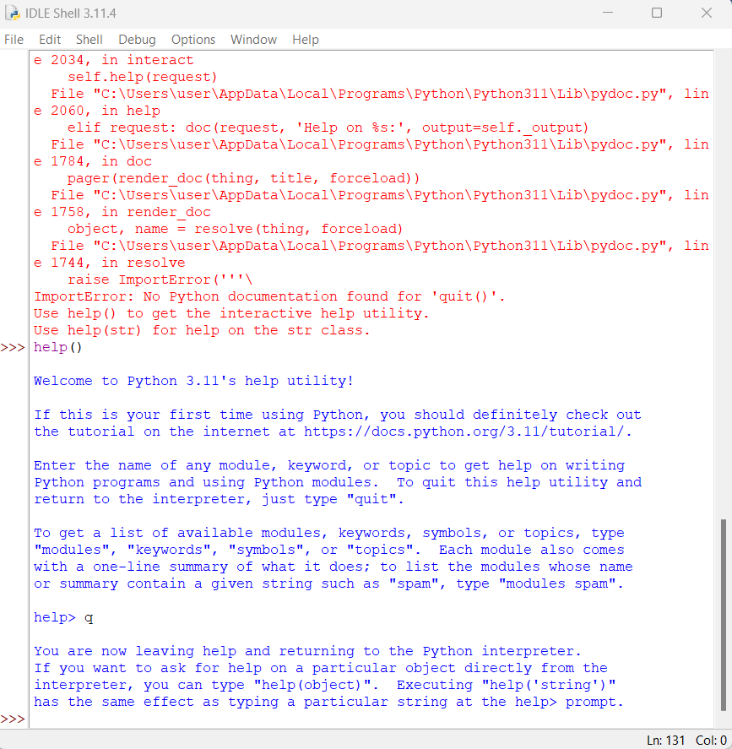

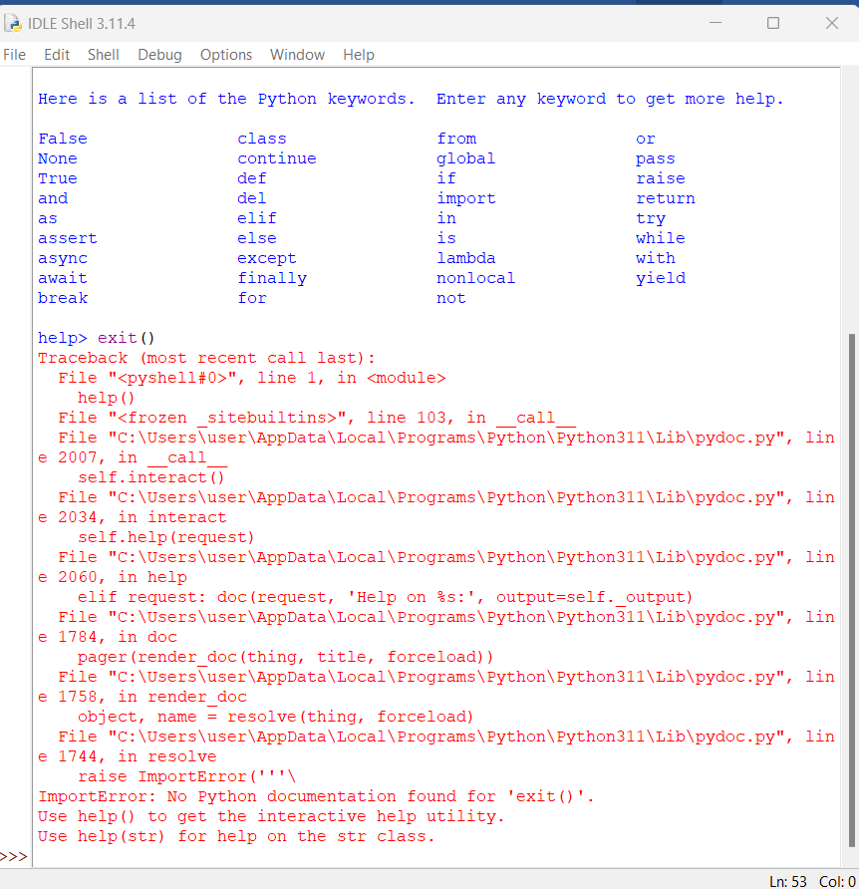

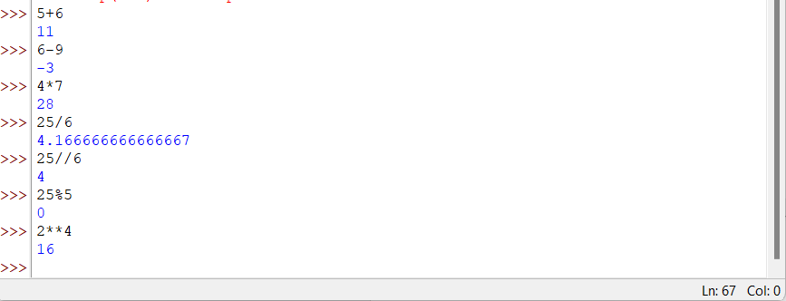

**Week -2:77**

1. If you run a 10 kilometer race in 43 minutes 30 seconds, what is your average time per mile? What is your average speed in miles per hour? (Hint: there are 1.61 kilometers in a mile).

minutes = 43.5

hours = minutes / 60

km_per_mile = 1.61

km = 10

miles = km / km_per_mile

tpm = minutes / miles

mph = miles / hours

print('Average time per mile:', tpm)

print('Average speed in mph:', mph)

Output:

Average time per mile: 7.003500000000001

Average speed in mph: 8.567144998929106

1. Find the volume of a sphere with radius r is 5? (Use Sphere volume formula)

pi = 3.1415926535897931

r = 5

V= 4.0/3.0*pi* r**3

print('The volume of the sphere is: ',V)

**output**

The volume of the sphere is: 523.5987755982989

1. Suppose the cover price of a book is $24.95, but bookstores get a 40% discount.

Shipping costs $3 for the first copy and 75 cents for each additional copy. What is the

total wholesale cost for 60 copies?

bookCost = 24.95

numBooks = 60.0

def cost(numBooks):

bulkBookCost = ((bookCost * 0.60) * numBooks)

shippingCost = (3.0 + (0.75 * (numBooks - 1)))

totalCost = bulkBookCost + shippingCost

print ('The total cost is: $', totalCost)

cost(numBooks)

**Output**

The total cost is: $ 945.4499999999999